R. Reports Menu: 9. State Statistics Report

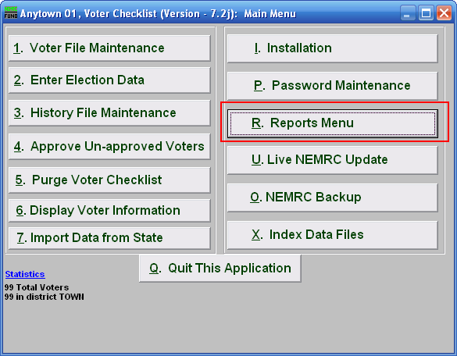
Click on “R. Reports Menu” from the Main Menu and the following window will appear:

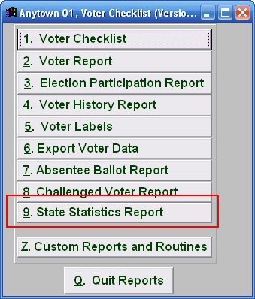
Click on “9. State Statistics Report” from the Reports Menu and the following window will appear:

State Statistics Report

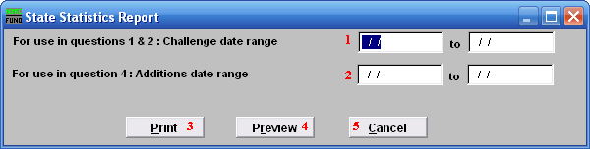
- For use in questions 1 & 2 : Challenge date range: Enter the date you want to start with to the date you want to end with.

- For use in question 4: Additions date range: Enter the date you want to start with to the date you want to end with.

- Print: Click this button to print. Refer to GENERAL PRINTING for more information.

- Preview: Click this button to preview. Refer to GENERAL PREVIEW for more information.

- Cancel: Click “Cancel” to cancel and return to the previous screen.

